CPE301 – SPRING 2019

MIDTERM II

Student Name: John Duriman

Student #: 5002373995

Student Email: duriman@unlv.nevada.edu

Primary Github address: https://github.com/johnduriman/pirahnaplant.git

Directory: pirahnaplant/Midterms/Midterm II

Submit the following for all Labs:

1. In the document, for each task submit the modified or included code (only) with highlights and justifications of the modifications. Also, include the comments.
2. Use the previously create a Github repository with a random name (no CPE/301, Lastname, Firstname). Place all labs under the root folder ESD301/DA, sub-folder named LABXX, with one document and one video link file for each lab, place modified asm/c files named as LabXX-TYY.asm/c.
3. If multiple asm/c files or other libraries are used, create a folder LabXX-TYY and place these files inside the folder.
4. The folder should have a) Word document (see template), b) source code file(s) and other include files, c) text file with youtube video links (see template).

1. **COMPONENTS LIST AND CONNECTION BLOCK DIAGRAM w/ PINS**

Parts used:

ESP8266 ESP01 WiFi module

5V Serial to USB Converter

Atmega 328P

Breadboard

Jumper wires

APDS 9960

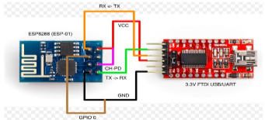To program the ESP01, I wired it with the converter using this schematic

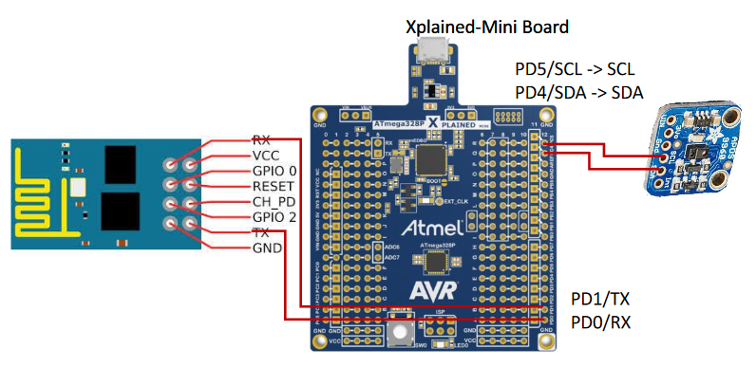Once programmed, I hooked up the APDS 9960 to the ATMEGA328P and used PD5 for SCL and PD4 for SDA.

1. **INITIAL/MODIFIED/DEVELOPED CODE OF TASK 1/A**

1. **SCREENSHOTS OF EACH TASK OUTPUT**

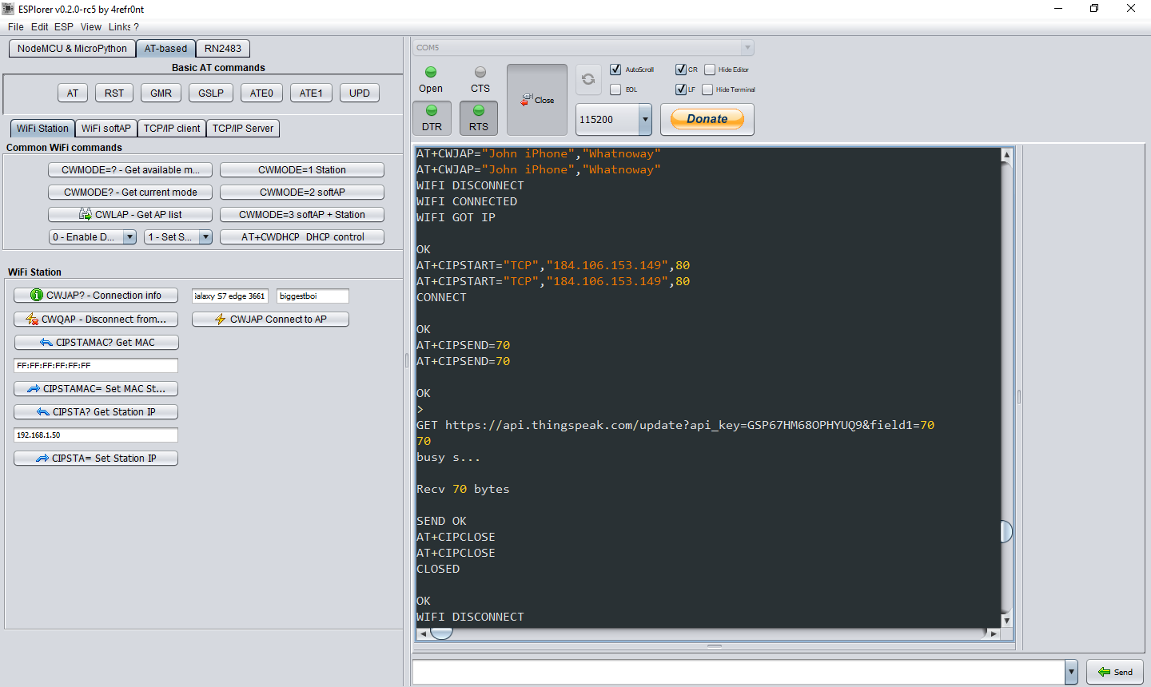

1. **SCREENSHOT OF EACH DEMO (BOARD SETUP)**

Here is what the ESP looked like when it was getting programmed.

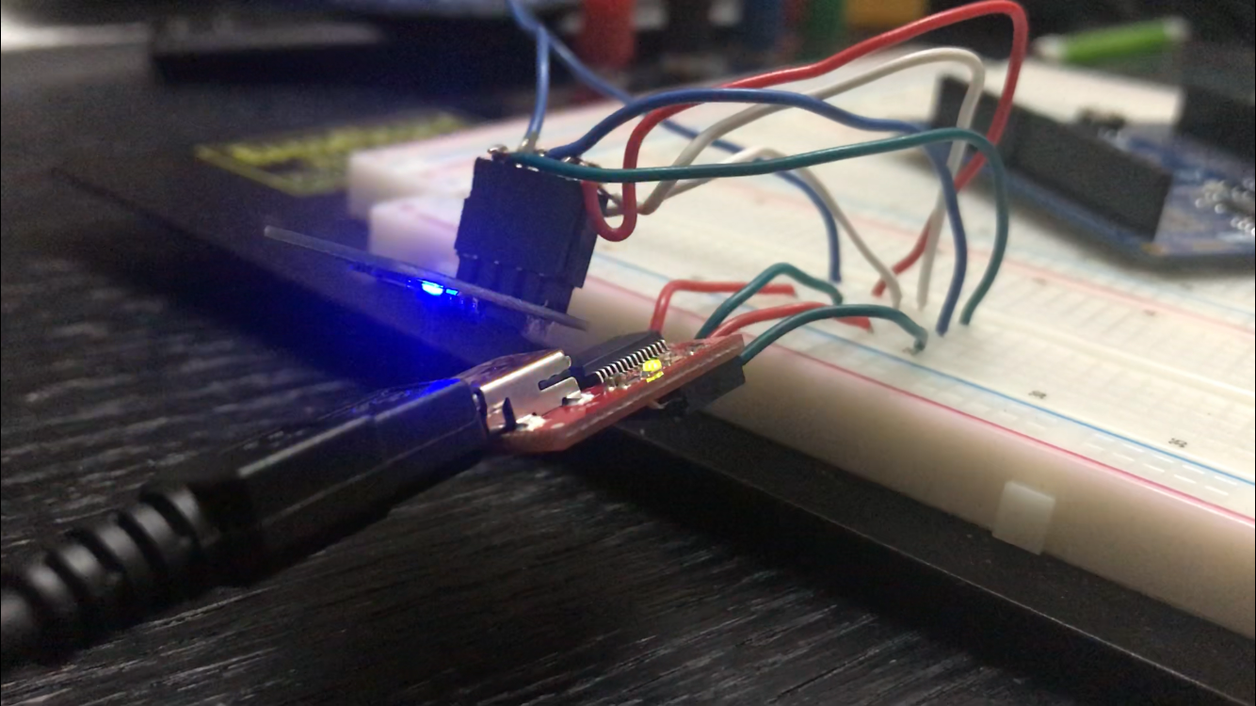

Here is the initial setup of the APDS 9960

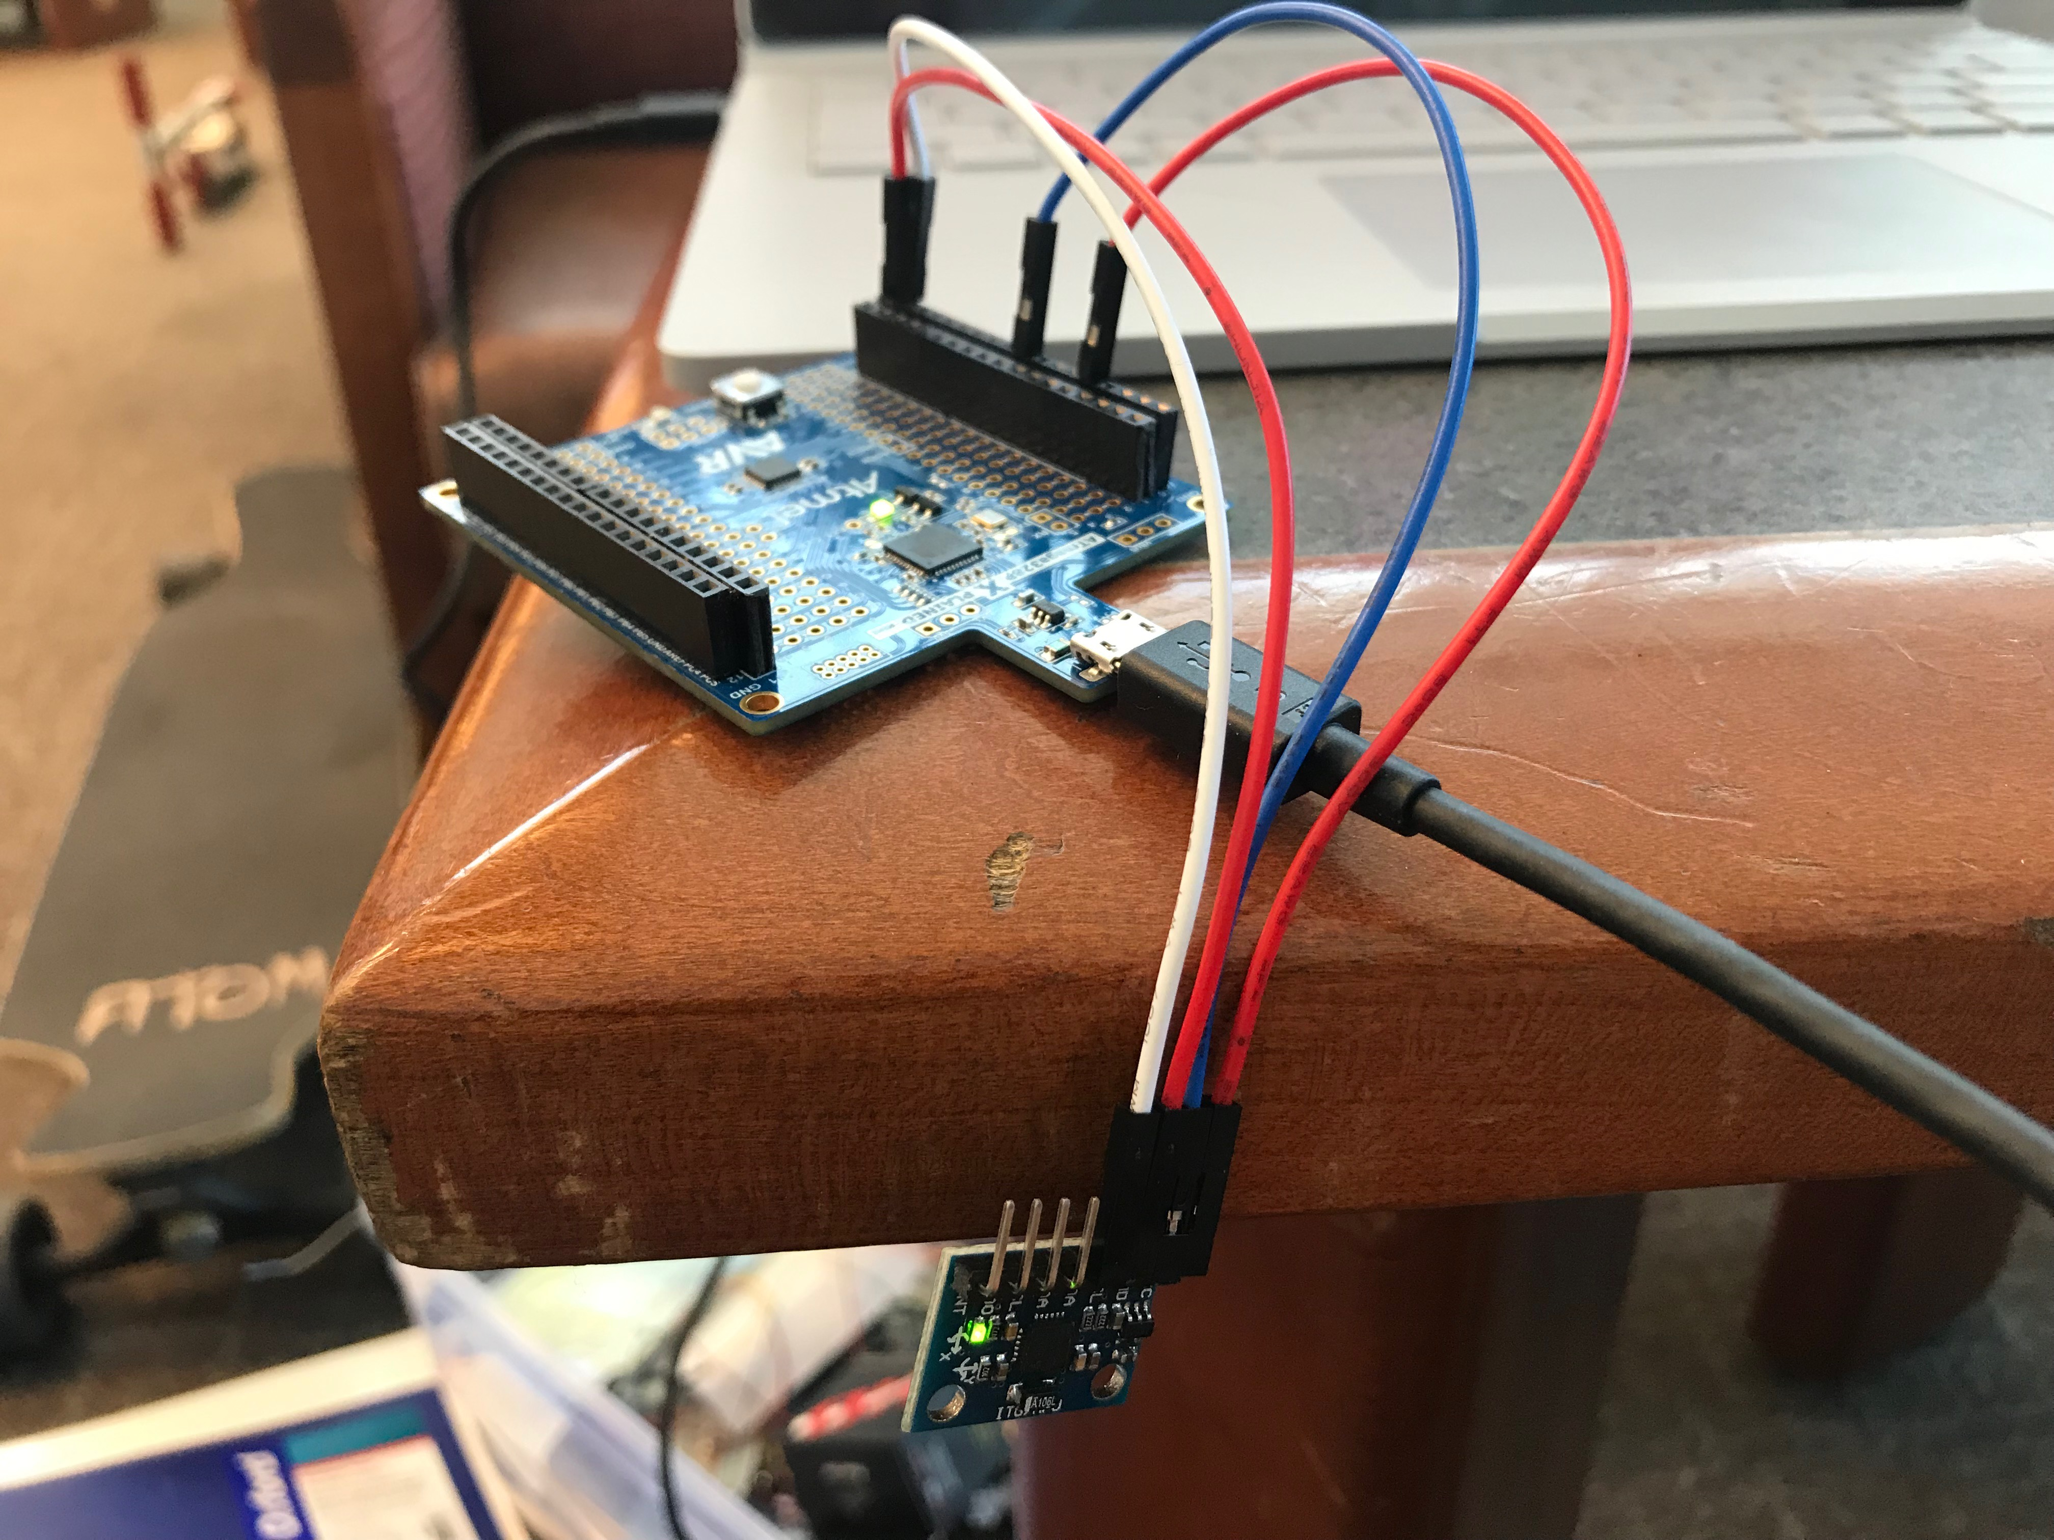

1. **VIDEO LINKS OF EACH DEMO**
2. **GITHUB LINK OF THIS DA**

https://github.com/johnduriman/pirahnaplant.git

**Student Academic Misconduct Policy**

<http://studentconduct.unlv.edu/misconduct/policy.html>

“This assignment submission is my own, original work”.

John Duriman